Practical 1:
Initiate the semester-long StudentHub portal by identifying the problem scope, user roles, key modules, navigation flow, and minimum 10 pages. Create a sitemap, low-fidelity wireframe, project folder structure, README file, and GitHub repository.
Wireframe Structure:
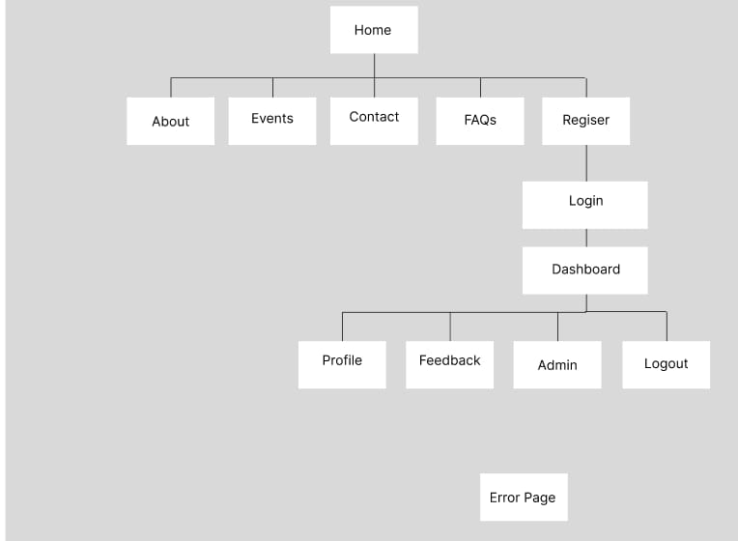
Figure 1 The Wireframe
Sitemaps:
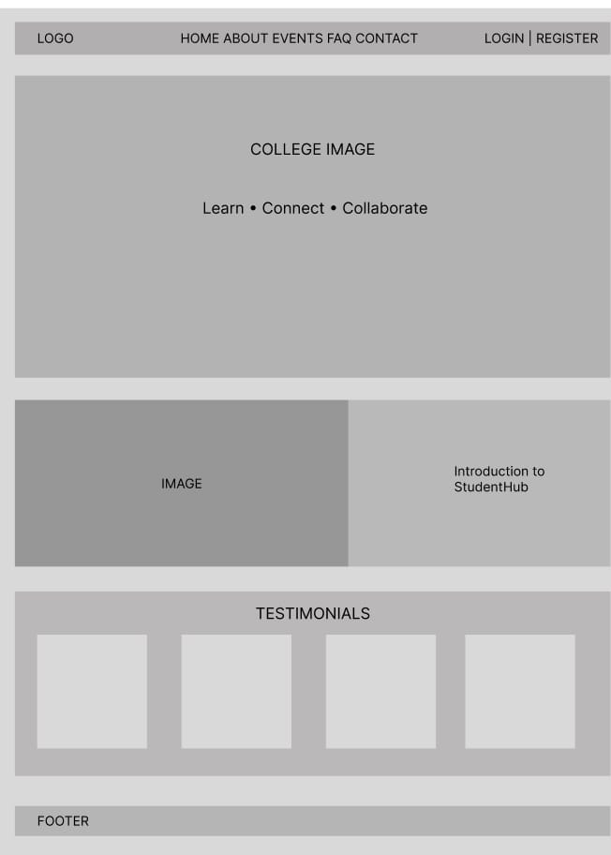
Figure 2 Home Page
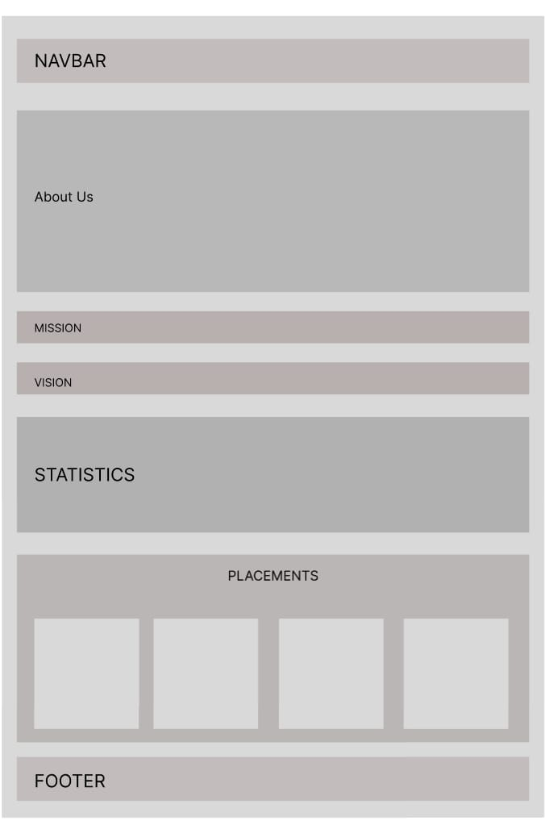
Figure 3 About Page
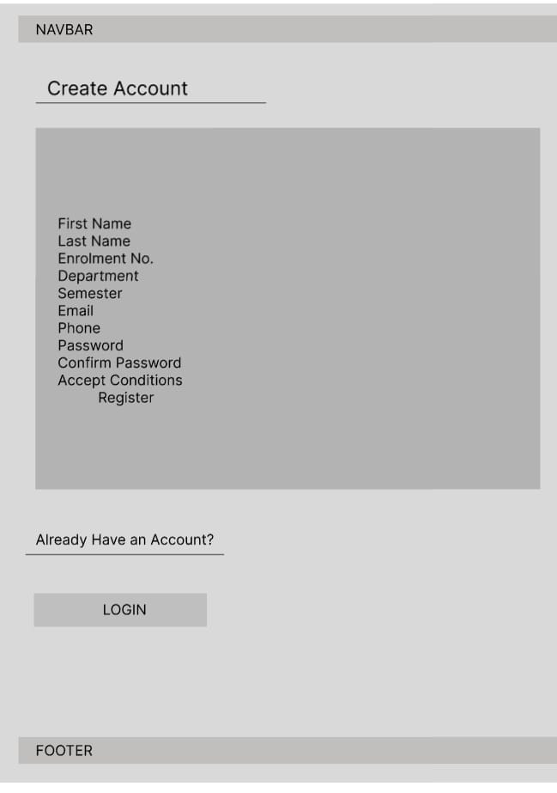
Figure 3 Register page
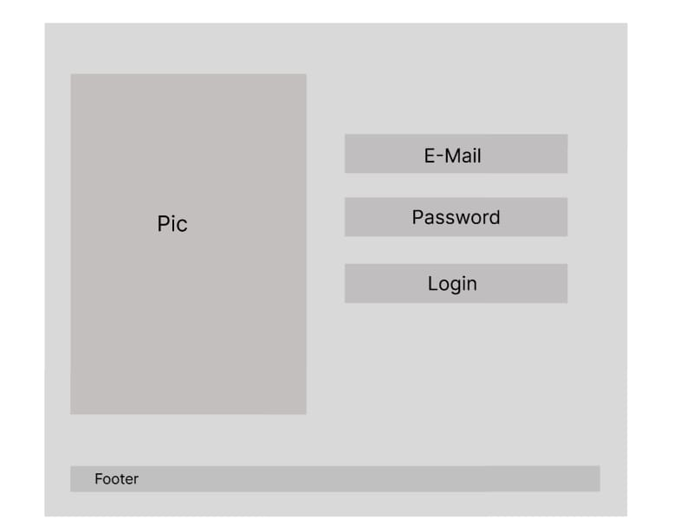
Figure 4 Login Page
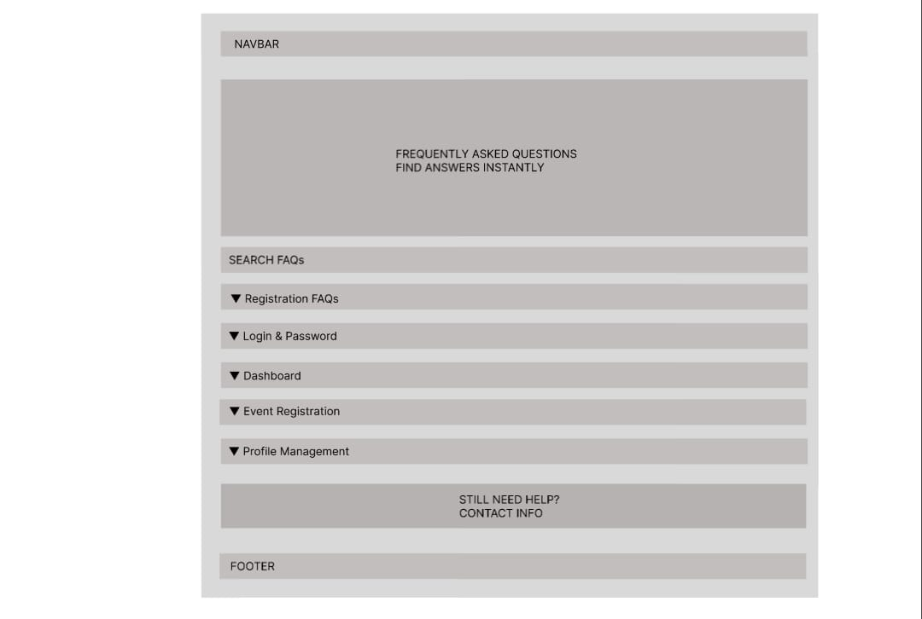
Figure 5 FAQ Page
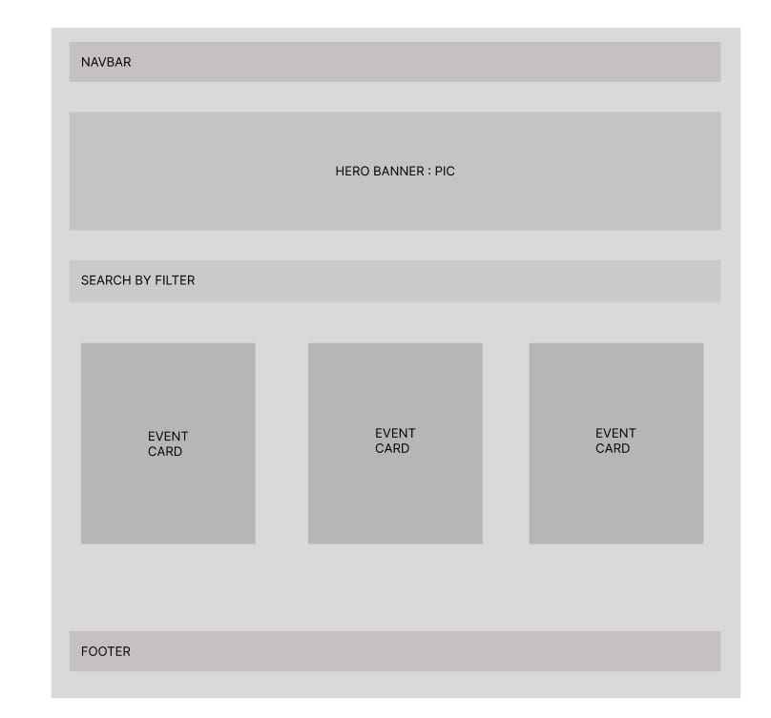
Figure 6 Events Page
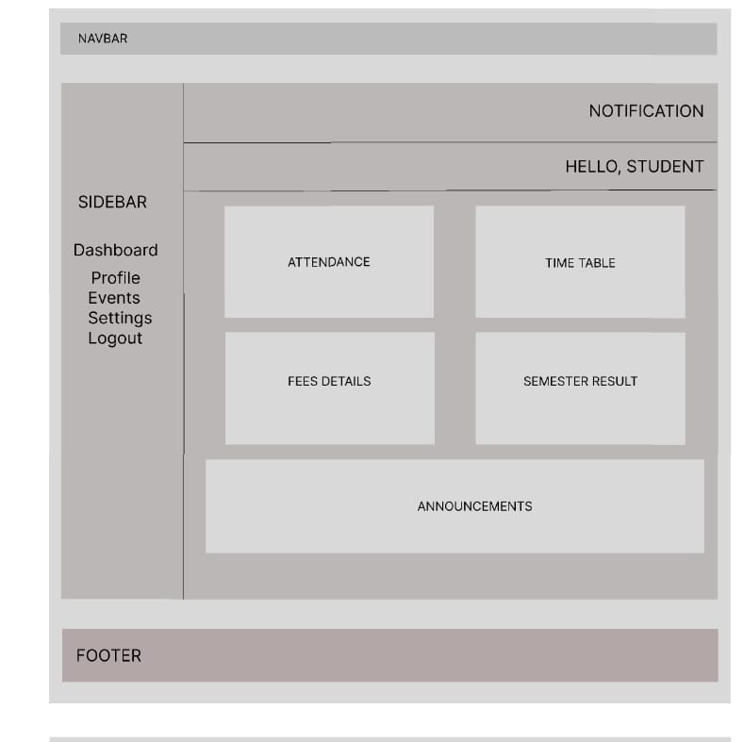
Figure 7 Profile Page
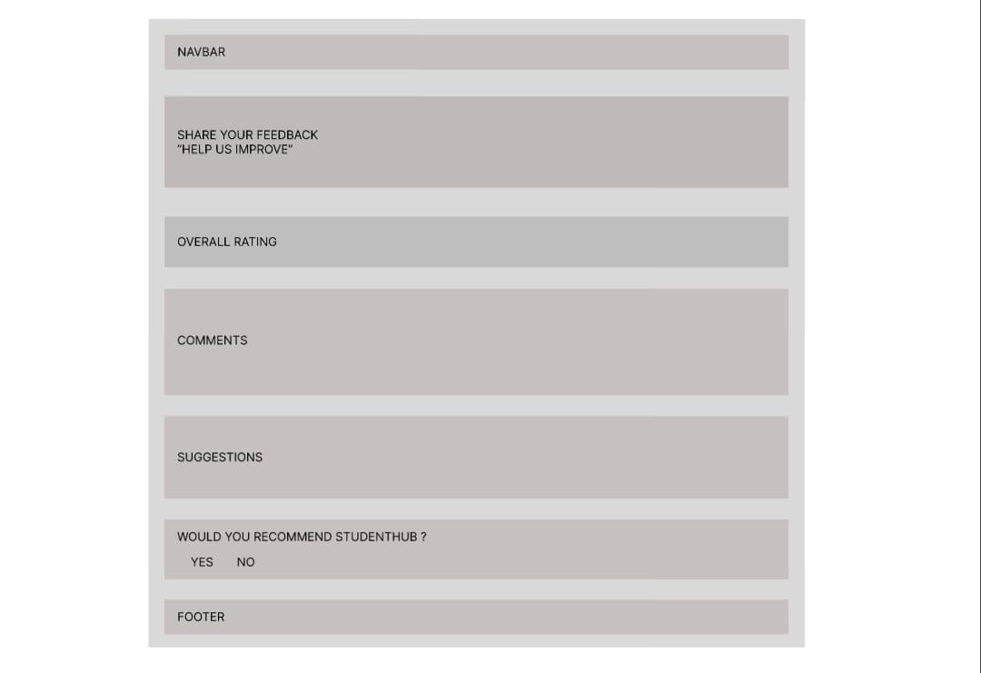
Figure 8 Feedback Page
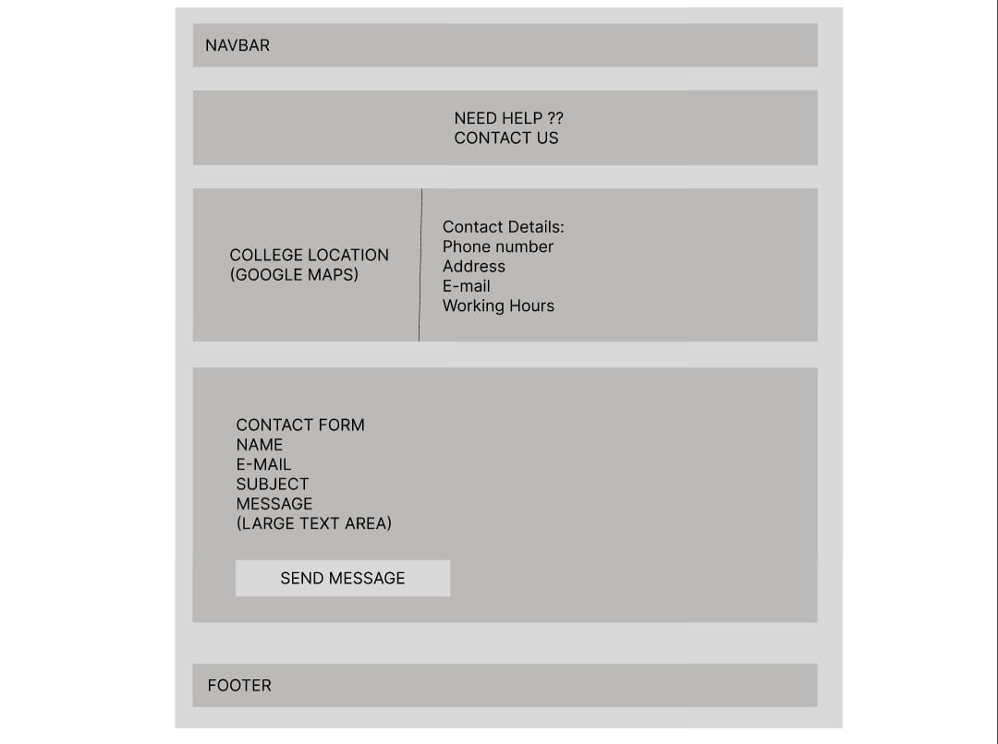
Figure 9 Contact Page
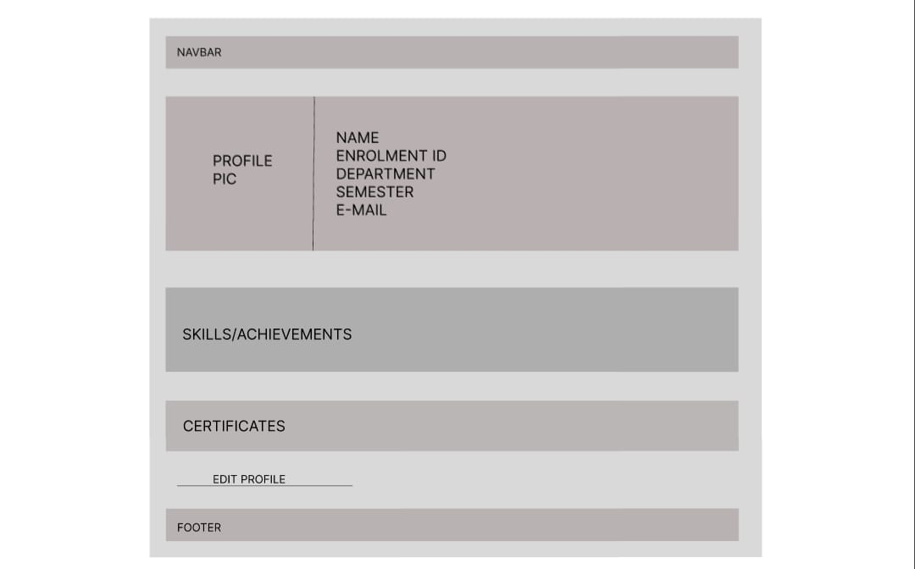
Figure 10 Admin Page

